Spørreundersøkelse Involve  
*Spørreundersøkelse Involve*  
**April 27th 2019, 3:28 am MDT**

**Q1 - Jeg opplever lederen min som en god rollemodell**

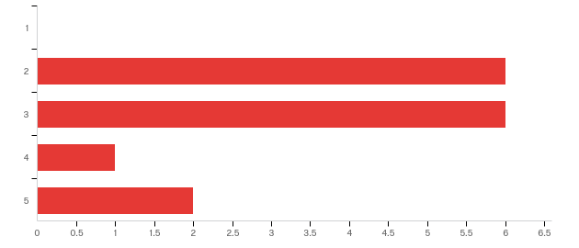

|  |  |  |  |  |  |  |  |
| --- | --- | --- | --- | --- | --- | --- | --- |
| # | Field | Minimum | Maximum | Mean | Std Deviation | Variance | Count |
| 1 | Jeg opplever lederen min som en god rollemodell | 2.00 | 5.00 | 2.93 | 1.00 | 1.00 | 15 |

|  |  |  |  |
| --- | --- | --- | --- |
| # | Answer | % | Count |
| 1 | 1 | 0.00% | 0 |
| 2 | 2 | 40.00% | 6 |
| 3 | 3 | 40.00% | 6 |
| 4 | 4 | 6.67% | 1 |
| 5 | 5 | 13.33% | 2 |
|  | Total | 100% | 15 |

**Q2 - Lederen opptrer i tråd med Involve's visjon og verdier**

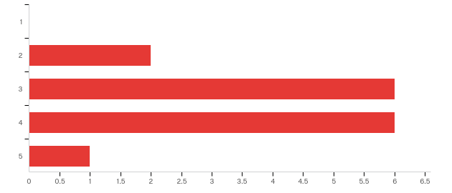

|  |  |  |  |  |  |  |  |
| --- | --- | --- | --- | --- | --- | --- | --- |
| # | Field | Minimum | Maximum | Mean | Std Deviation | Variance | Count |
| 1 | Lederen opptrer i tråd med Involve's visjon og verdier | 2.00 | 5.00 | 3.40 | 0.80 | 0.64 | 15 |

|  |  |  |  |
| --- | --- | --- | --- |
| # | Answer | % | Count |
| 1 | 1 | 0.00% | 0 |
| 2 | 2 | 13.33% | 2 |
| 3 | 3 | 40.00% | 6 |
| 4 | 4 | 40.00% | 6 |
| 5 | 5 | 6.67% | 1 |
|  | Total | 100% | 15 |

**Q3 - Lederen motiverer og inspirerer meg til å yte mitt beste**

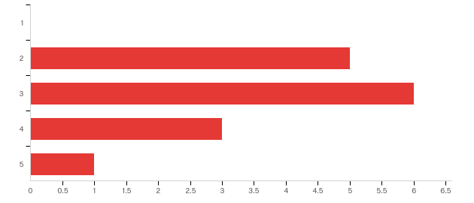

|  |  |  |  |  |  |  |  |
| --- | --- | --- | --- | --- | --- | --- | --- |
| # | Field | Minimum | Maximum | Mean | Std Deviation | Variance | Count |
| 1 | Lederen motiverer og inspirerer meg til å yte mitt beste | 2.00 | 5.00 | 3.00 | 0.89 | 0.80 | 15 |

|  |  |  |  |
| --- | --- | --- | --- |
| # | Answer | % | Count |
| 1 | 1 | 0.00% | 0 |
| 2 | 2 | 33.33% | 5 |
| 3 | 3 | 40.00% | 6 |
| 4 | 4 | 20.00% | 3 |
| 5 | 5 | 6.67% | 1 |
|  | Total | 100% | 15 |

**Q4 - Ledelsen får oss til å føle en sterk tilhørighet til Involve**

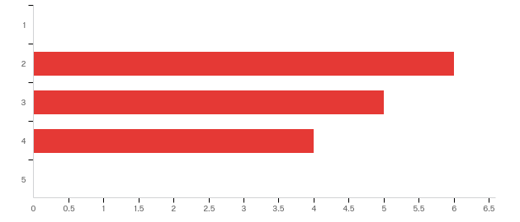

|  |  |  |  |  |  |  |  |
| --- | --- | --- | --- | --- | --- | --- | --- |
| # | Field | Minimum | Maximum | Mean | Std Deviation | Variance | Count |
| 1 | Ledelsen får oss til å føle en sterk tilhørighet til Involve | 2.00 | 4.00 | 2.87 | 0.81 | 0.65 | 15 |

|  |  |  |  |
| --- | --- | --- | --- |
| # | Answer | % | Count |
| 1 | 1 | 0.00% | 0 |
| 2 | 2 | 40.00% | 6 |
| 3 | 3 | 33.33% | 5 |
| 4 | 4 | 26.67% | 4 |
| 5 | 5 | 0.00% | 0 |
|  | Total | 100% | 15 |

**Q5 - Lederen gir meg frihet til å være kreativ**

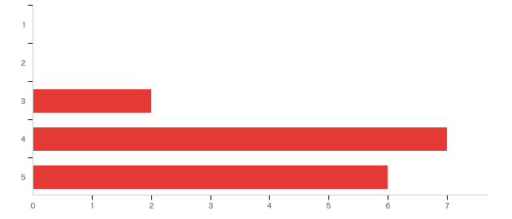

|  |  |  |  |  |  |  |  |
| --- | --- | --- | --- | --- | --- | --- | --- |
| # | Field | Minimum | Maximum | Mean | Std Deviation | Variance | Count |
| 1 | Lederen gir meg frihet til å være kreativ | 3.00 | 5.00 | 4.27 | 0.68 | 0.46 | 15 |

|  |  |  |  |
| --- | --- | --- | --- |
| # | Answer | % | Count |
| 1 | 1 | 0.00% | 0 |
| 2 | 2 | 0.00% | 0 |
| 3 | 3 | 13.33% | 2 |
| 4 | 4 | 46.67% | 7 |
| 5 | 5 | 40.00% | 6 |
|  | Total | 100% | 15 |

**Q6 - Lederen lytter til våre meninger ved viktige avgjørelser**

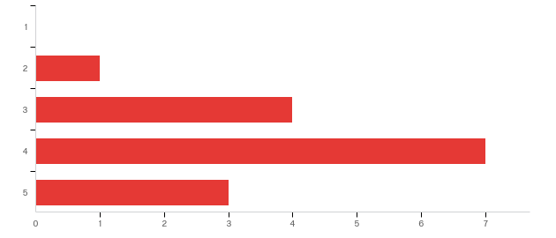

|  |  |  |  |  |  |  |  |
| --- | --- | --- | --- | --- | --- | --- | --- |
| # | Field | Minimum | Maximum | Mean | Std Deviation | Variance | Count |
| 1 | Lederen lytter til våre meninger ved viktige avgjørelser | 2.00 | 5.00 | 3.80 | 0.83 | 0.69 | 15 |

|  |  |  |  |
| --- | --- | --- | --- |
| # | Answer | % | Count |
| 1 | 1 | 0.00% | 0 |
| 2 | 2 | 6.67% | 1 |
| 3 | 3 | 26.67% | 4 |
| 4 | 4 | 46.67% | 7 |
| 5 | 5 | 20.00% | 3 |
|  | Total | 100% | 15 |

**Q7 - Lederen tar individuelle hensyn til meg og mine behov**

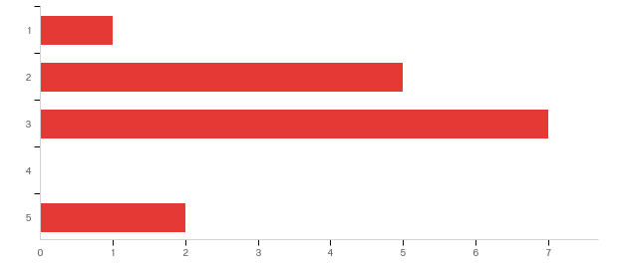

|  |  |  |  |  |  |  |  |
| --- | --- | --- | --- | --- | --- | --- | --- |
| # | Field | Minimum | Maximum | Mean | Std Deviation | Variance | Count |
| 1 | Lederen tar individuelle hensyn til meg og mine behov | 1.00 | 5.00 | 2.80 | 1.05 | 1.09 | 15 |

|  |  |  |  |
| --- | --- | --- | --- |
| # | Answer | % | Count |
| 1 | 1 | 6.67% | 1 |
| 2 | 2 | 33.33% | 5 |
| 3 | 3 | 46.67% | 7 |
| 4 | 4 | 0.00% | 0 |
| 5 | 5 | 13.33% | 2 |
|  | Total | 100% | 15 |

**Q8 - Lederen bidrar til at jeg utvikler meg i Involve**

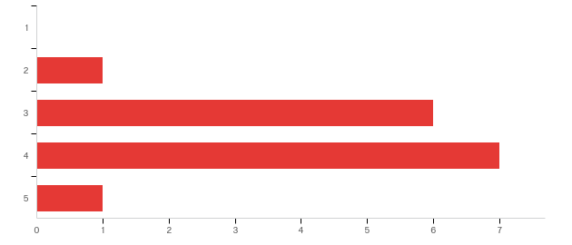

|  |  |  |  |  |  |  |  |
| --- | --- | --- | --- | --- | --- | --- | --- |
| # | Field | Minimum | Maximum | Mean | Std Deviation | Variance | Count |
| 1 | Lederen bidrar til at jeg utvikler meg i Involve | 2.00 | 5.00 | 3.53 | 0.72 | 0.52 | 15 |

|  |  |  |  |
| --- | --- | --- | --- |
| # | Answer | % | Count |
| 1 | 1 | 0.00% | 0 |
| 2 | 2 | 6.67% | 1 |
| 3 | 3 | 40.00% | 6 |
| 4 | 4 | 46.67% | 7 |
| 5 | 5 | 6.67% | 1 |
|  | Total | 100% | 15 |